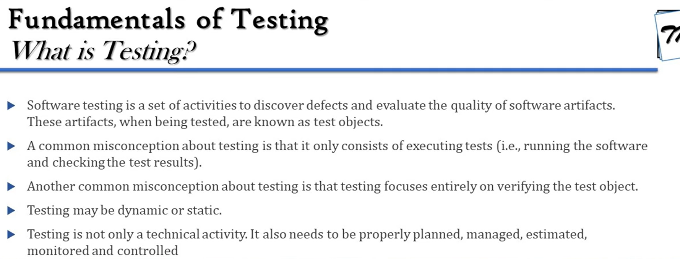

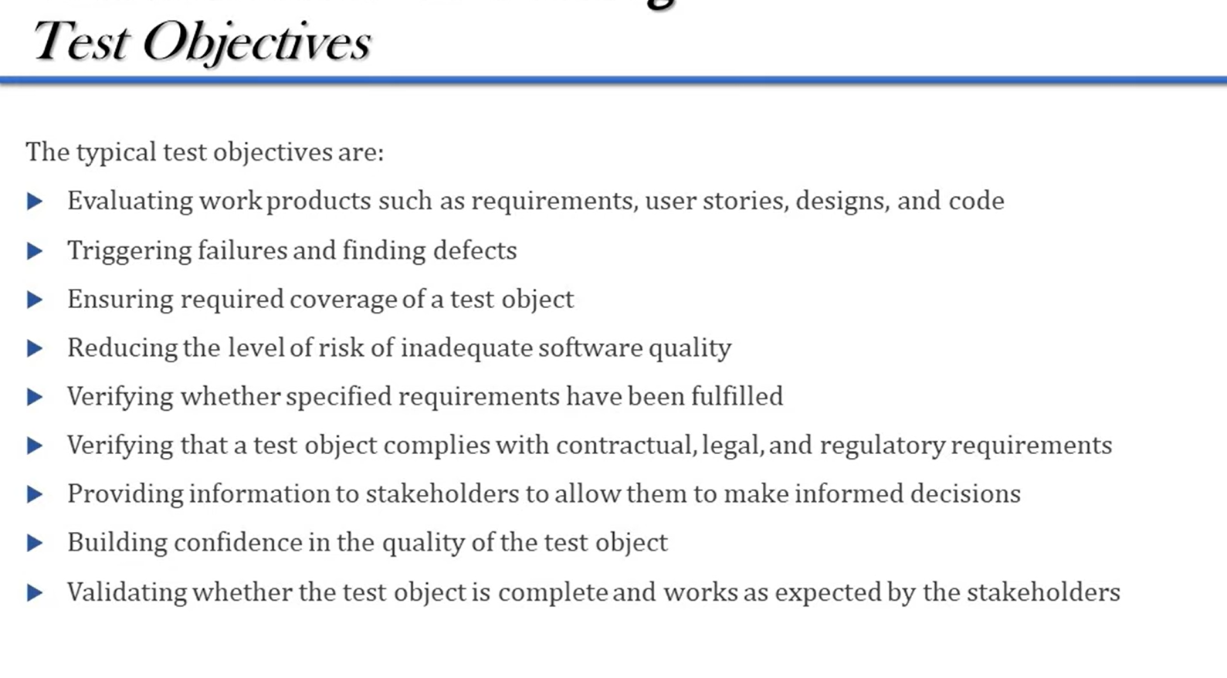

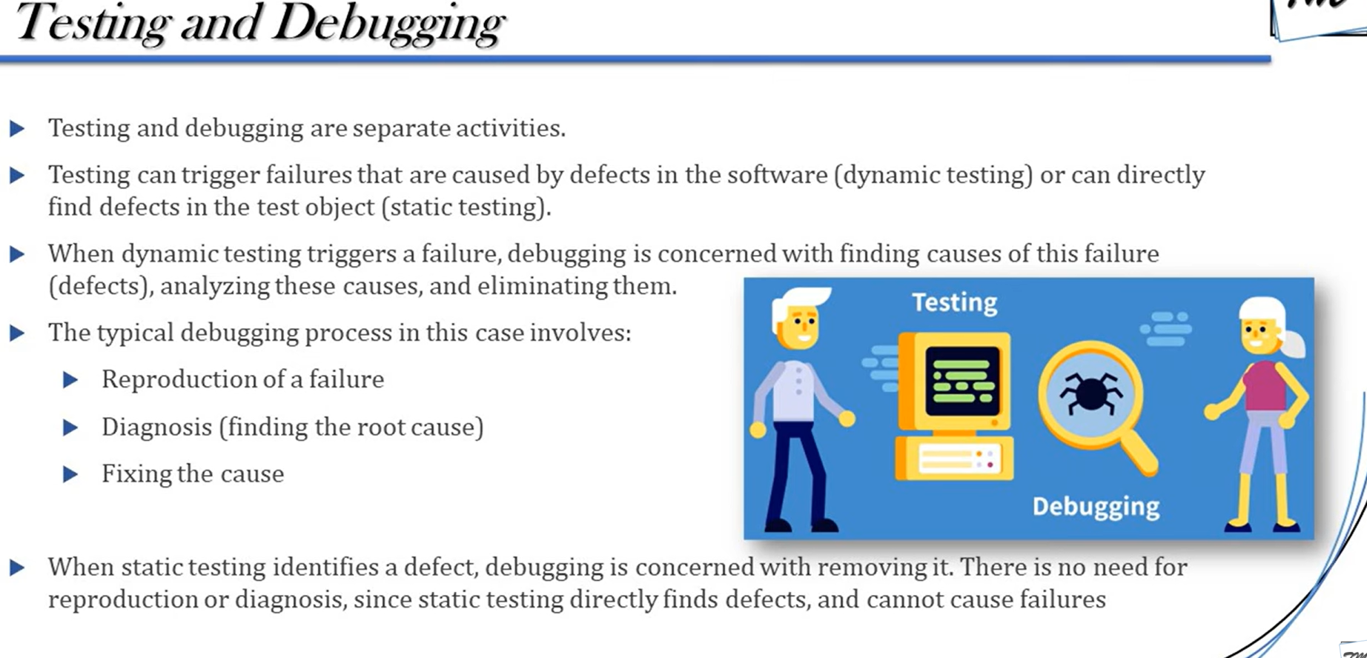

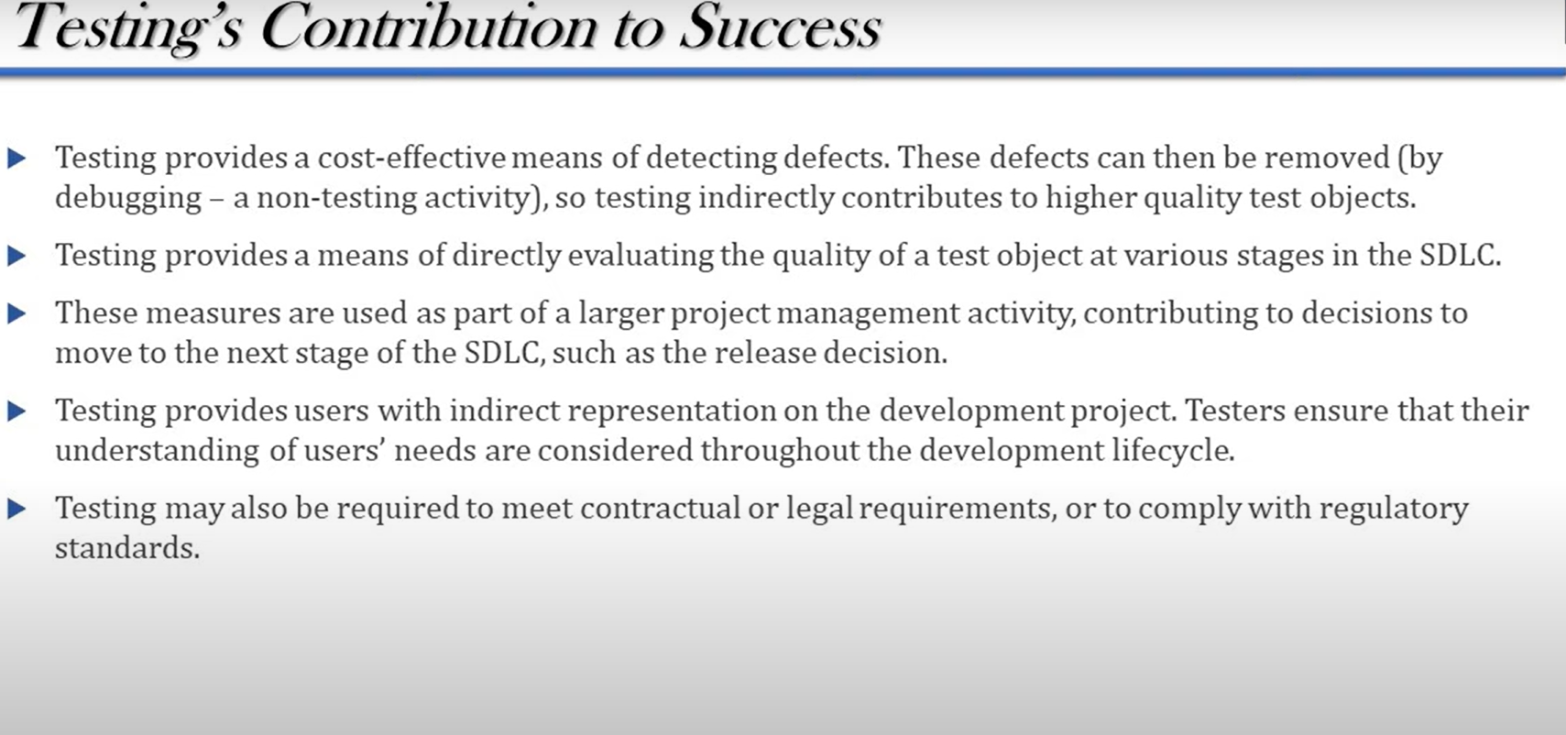

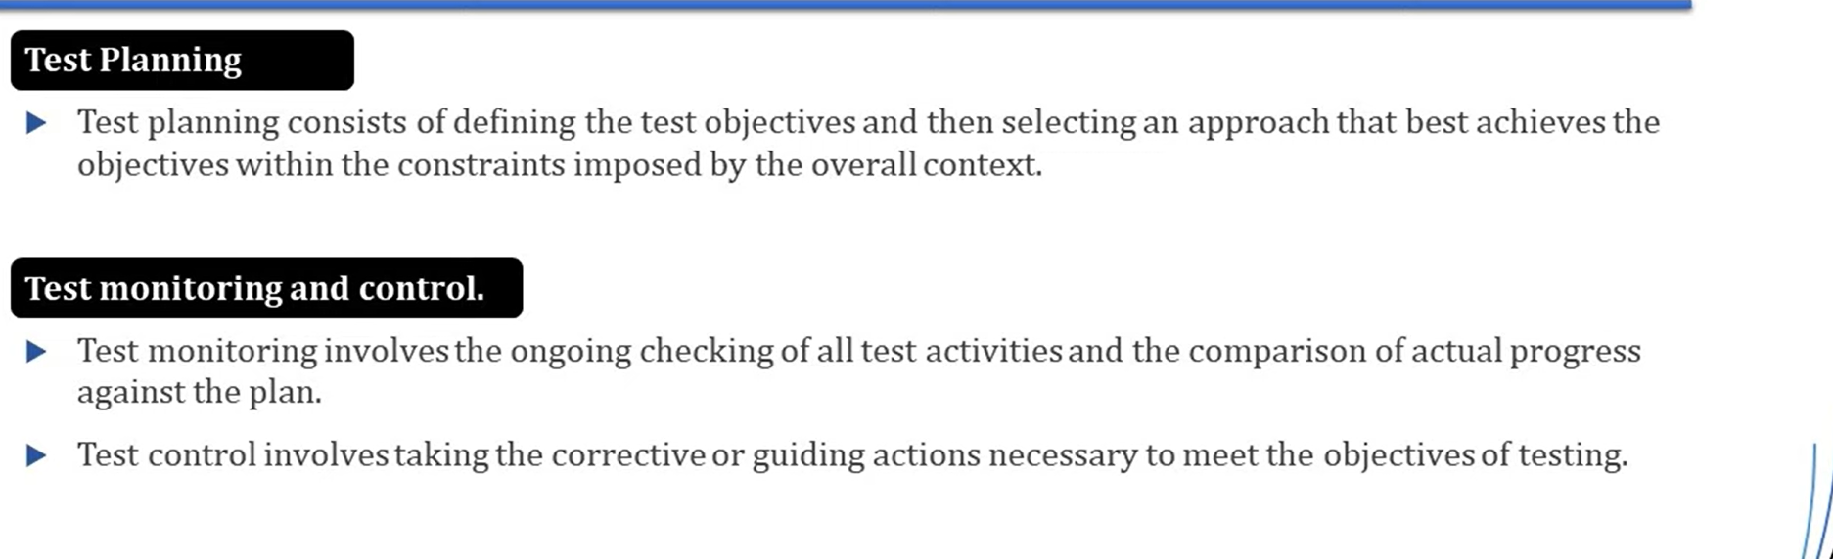

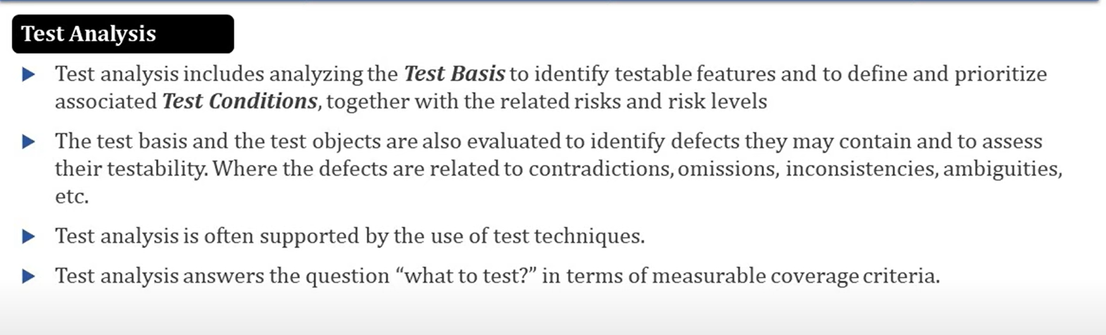

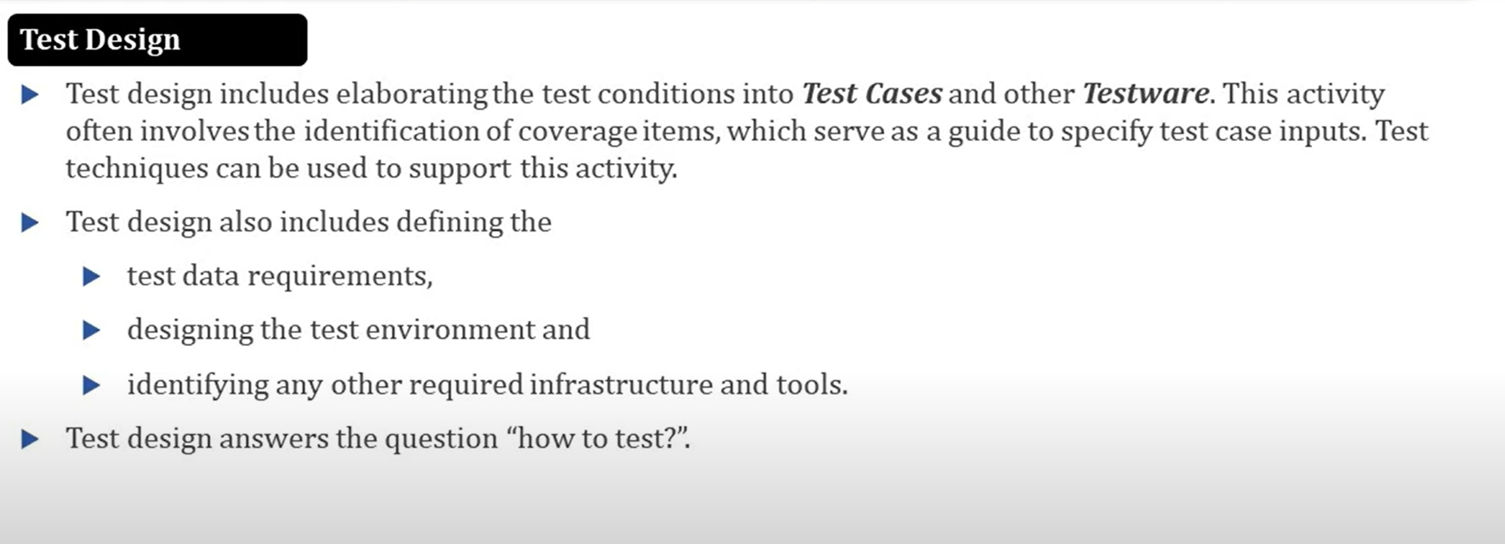

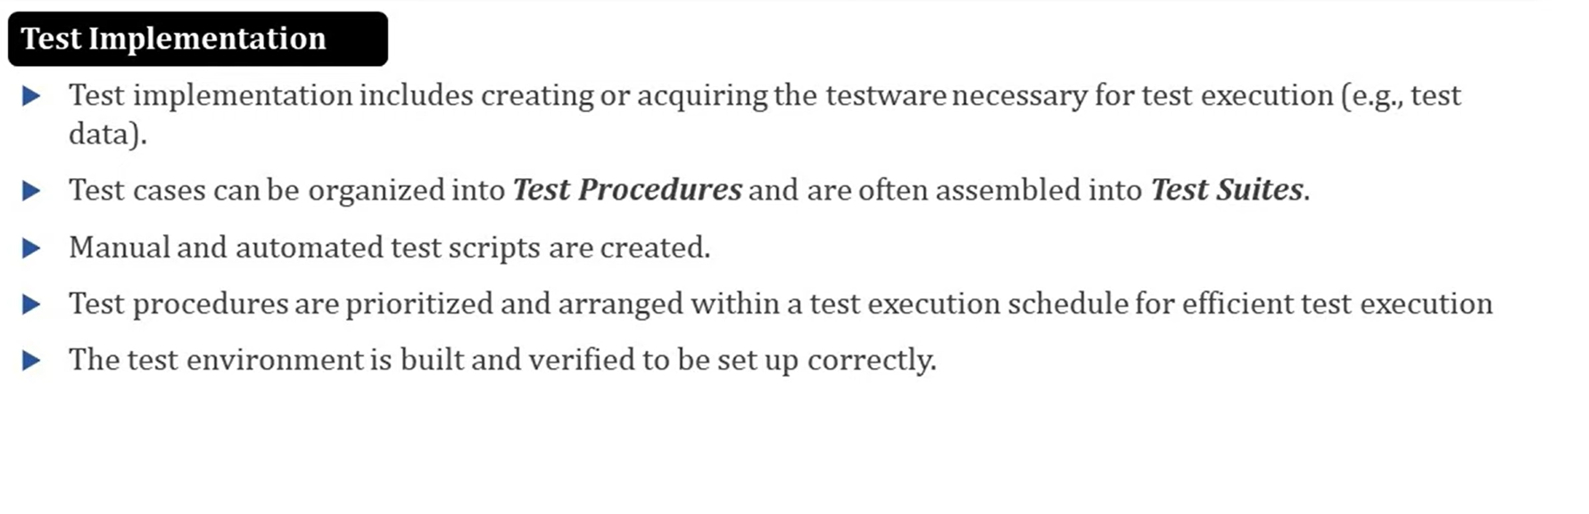

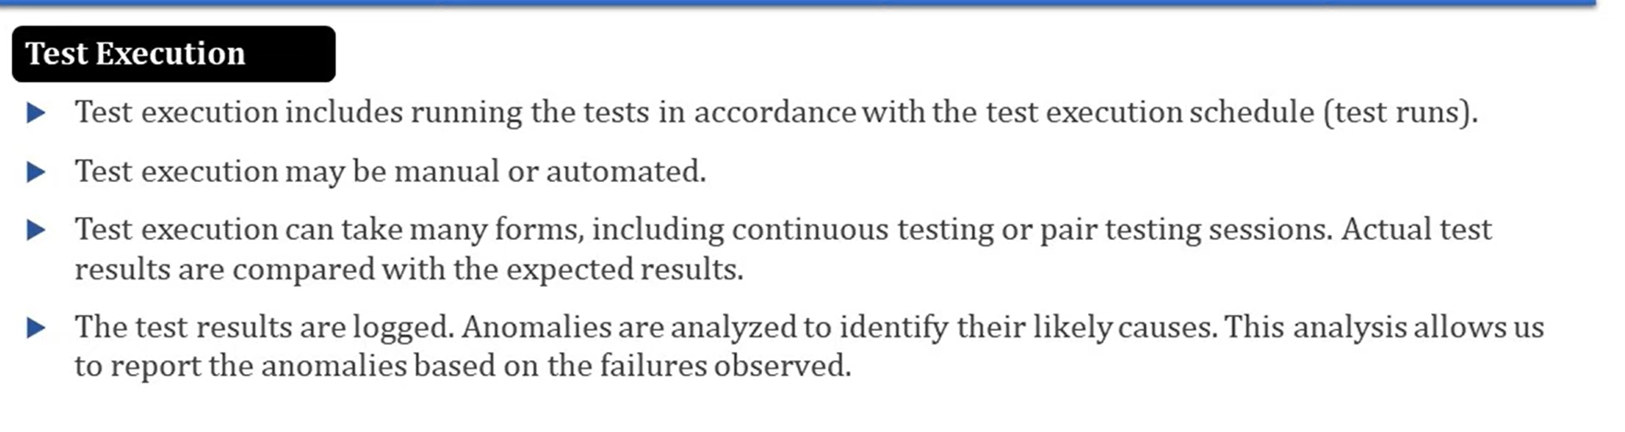

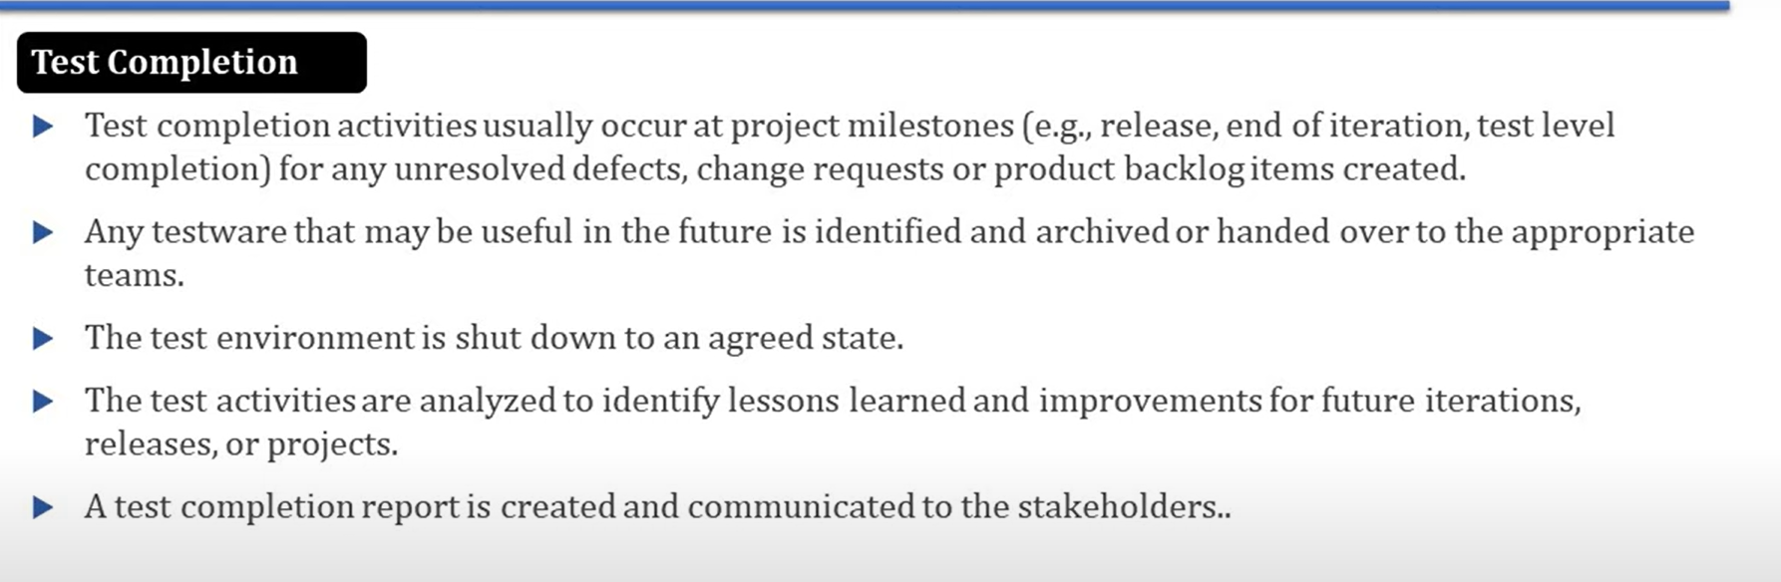

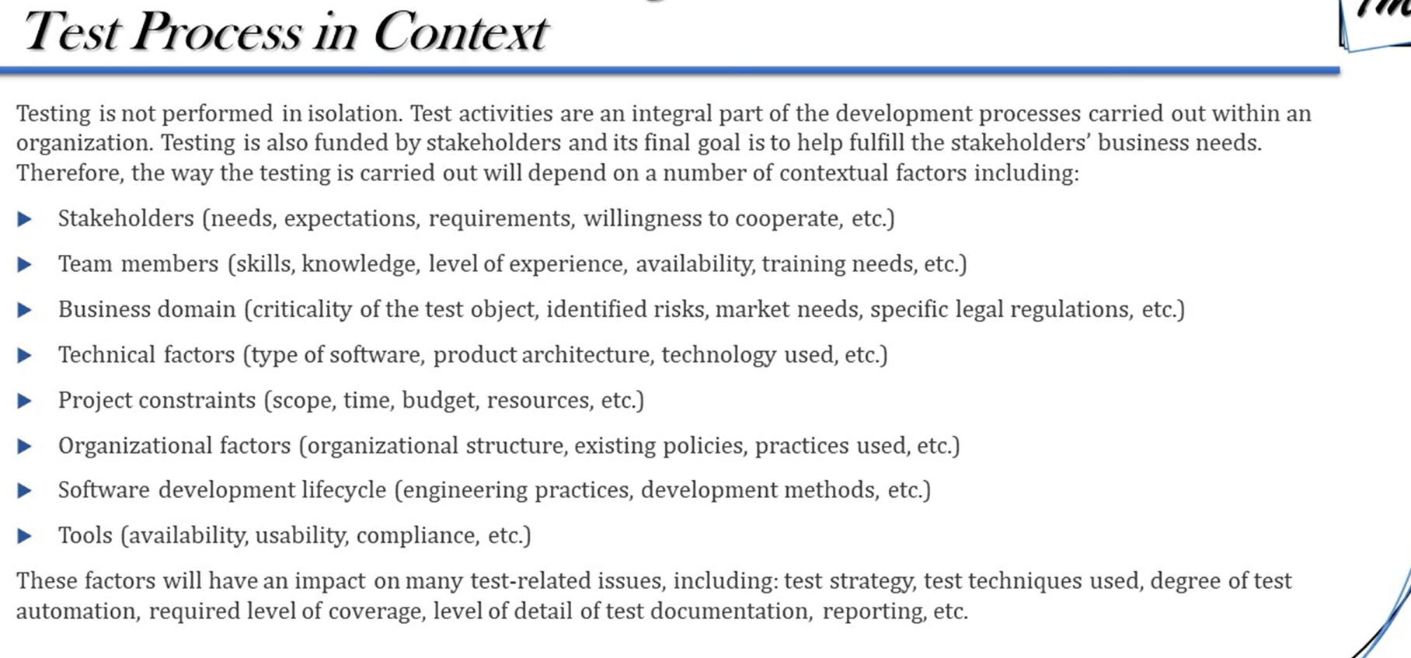

Quality Engineering is a broader concept that integrates quality assurance and quality control into the software development process

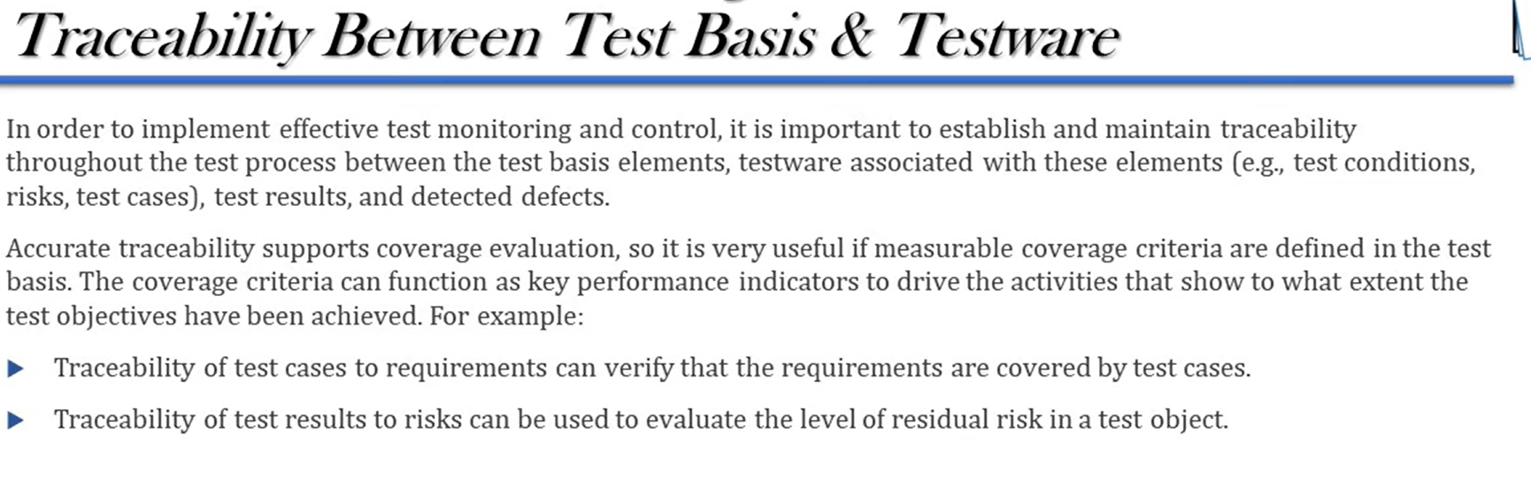

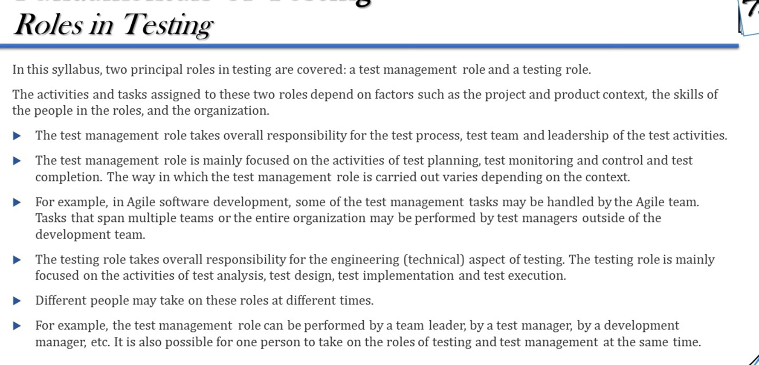

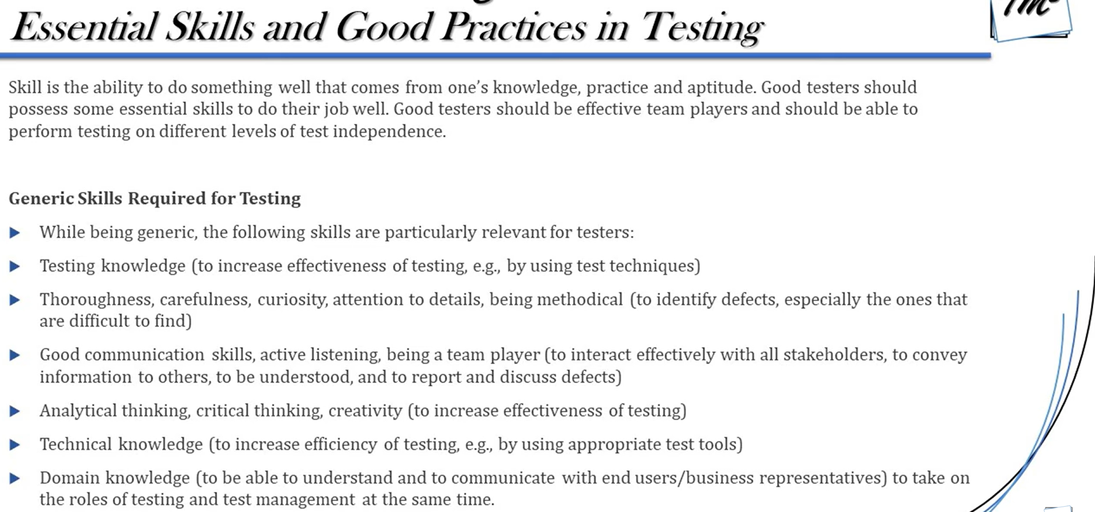

SDLC:

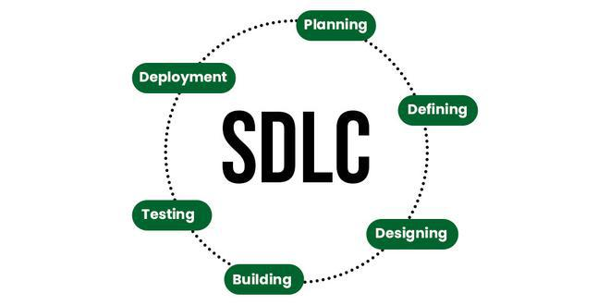

Planning and requirement analysis: scope of the project, what functionalities need to be included and quality assurance of the project, duration, are noted in the Software req specification (SRS) risk is calculated

Defining: SRS are reviewed by customers

Designing: SRS is input and divided into (design document specification) DDS ->low level (how to design component level) and high-level designs (what to design)

Development, testing, deployment, Maintenance

Examples of SDLC models include:

* sequential development models (e.g., waterfall model, V-model),
* iterative development models (e.g., spiral model, prototyping),
* incremental development models (e.g., Unified Process).
* Agile

Incremental : develop -> deploy Release 1 develop -> deploy (release2)

Iterative: develop -> test -> feedback again another loop without any deploy

Waterfall model:

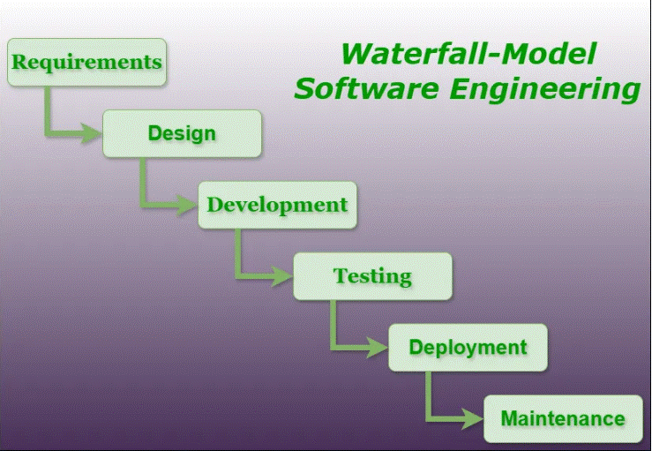

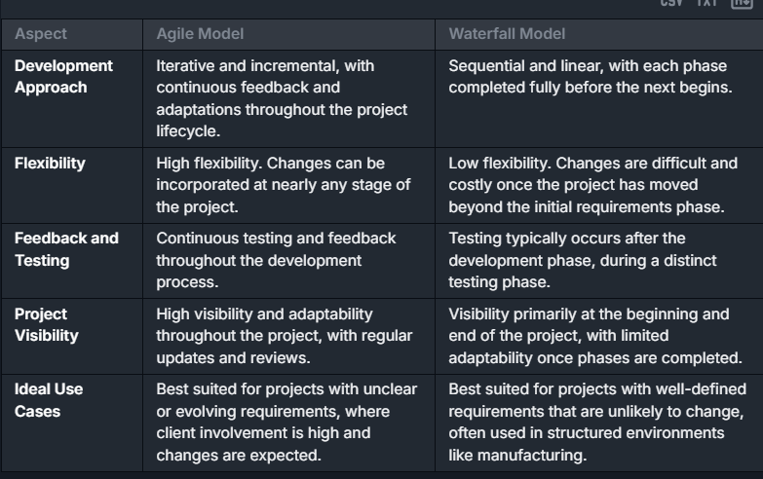

V-model: (verification, validation)

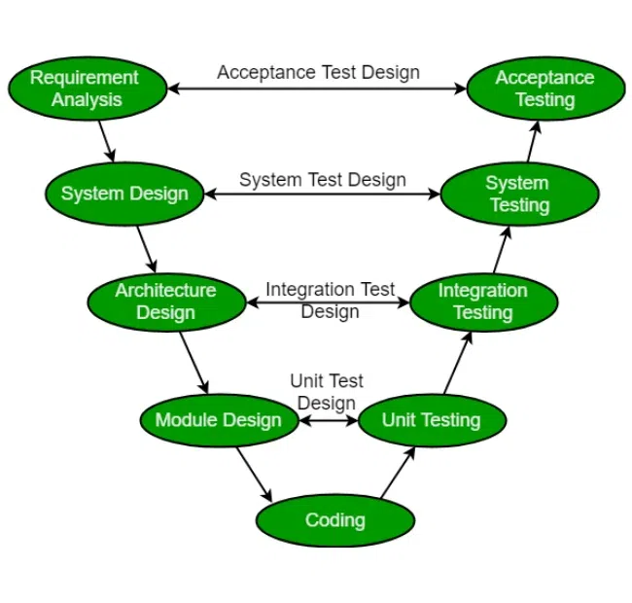

Spiral model: (Risk handling) sprints

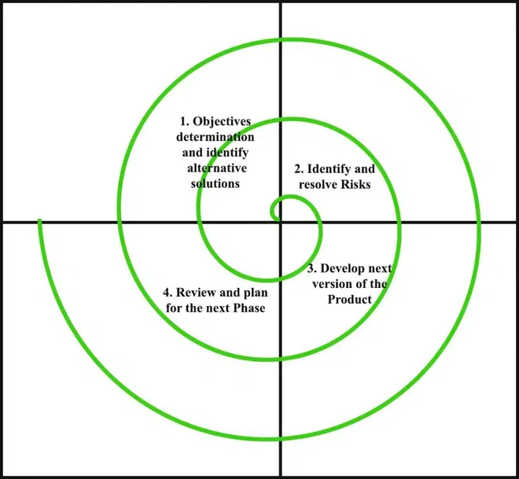

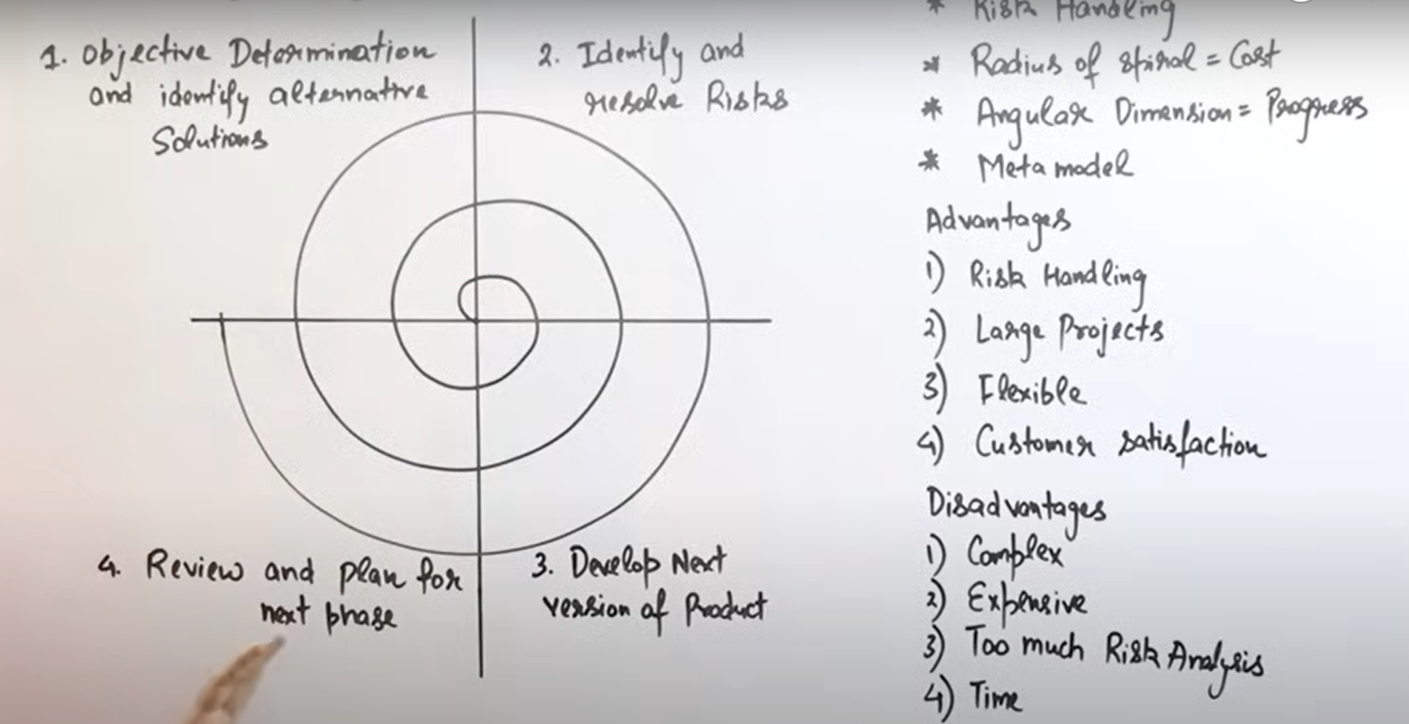

Prototype model: (feedback, entire development takes place)

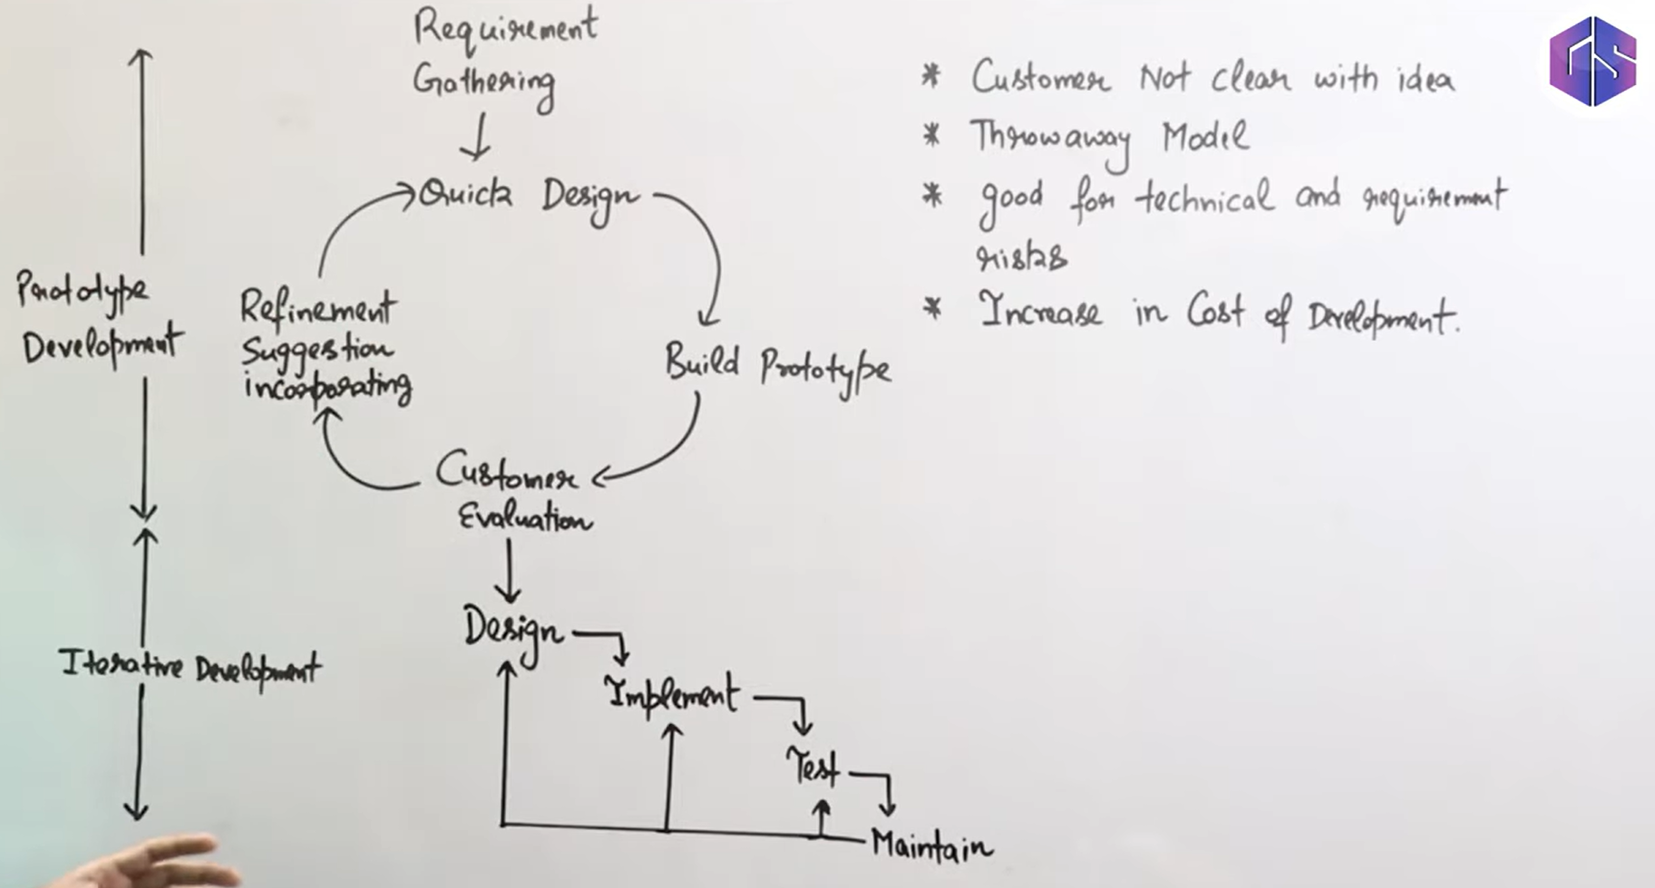

Unified model: (module by module development) not entirely features are developed in each release

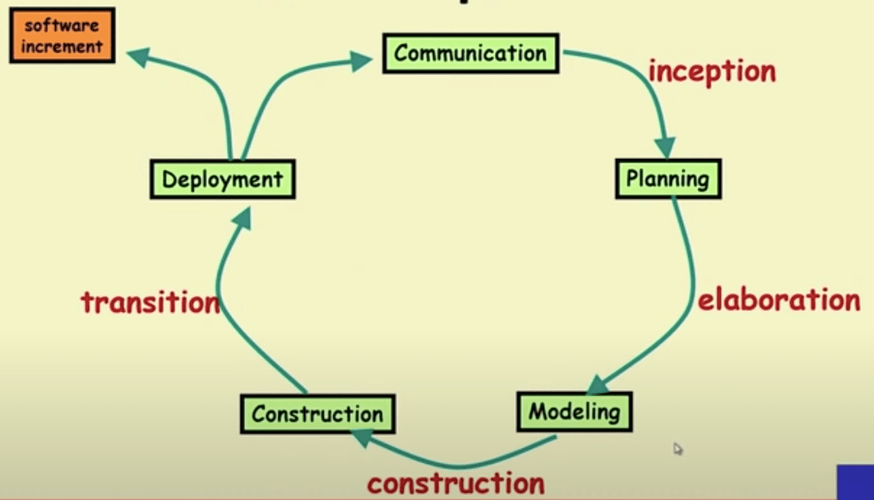

Agile model: (module by module, parallel, sprints)

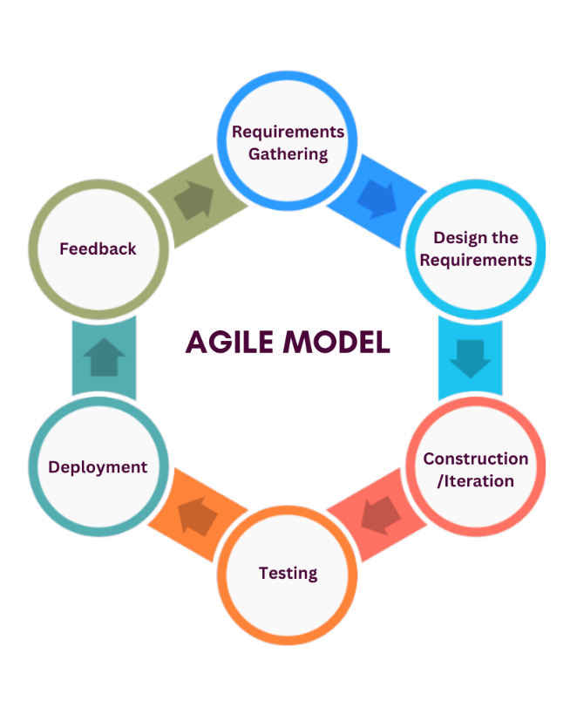

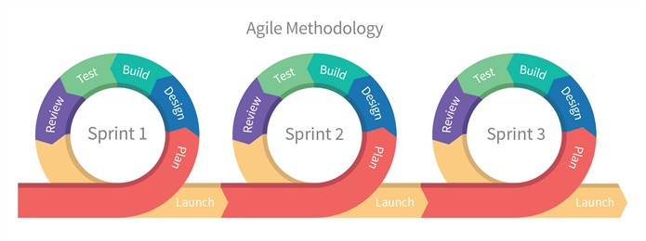

Some activities within software development processes can also be described by more detailed software development methods and Agile practices.

Examples include:

* acceptance test-driven development (ATDD),
* behavior-driven development (BDD),
* domain-driven design (DDD),
  + Domain-Driven Design (DDD) is an approach to software development that focuses on understanding and modeling the problem domain within which a software system operates.
  + It emphasizes the importance of collaborating closely with domain experts to develop a deep understanding of the domain’s intricacies and complexities.
  + DDD provides a set of principles, patterns, and practices to help developers effectively capture and express domain concepts in their software designs.
* extreme programming (XP),
  + Extreme Programming (XP) is an Agile software development methodology that focuses on delivering high-quality software through frequent and continuous feedback, collaboration, and adaptation.
  + XP emphasizes a close working relationship between the development team, the customer, and stakeholders, with an emphasis on rapid, iterative development and deployment.
  + [What is Extreme Programming (XP)? - GeeksforGeeks](https://www.geeksforgeeks.org/software-engineering-extreme-programming-xp/)
* feature-driven development (FDD),
* Kanban,

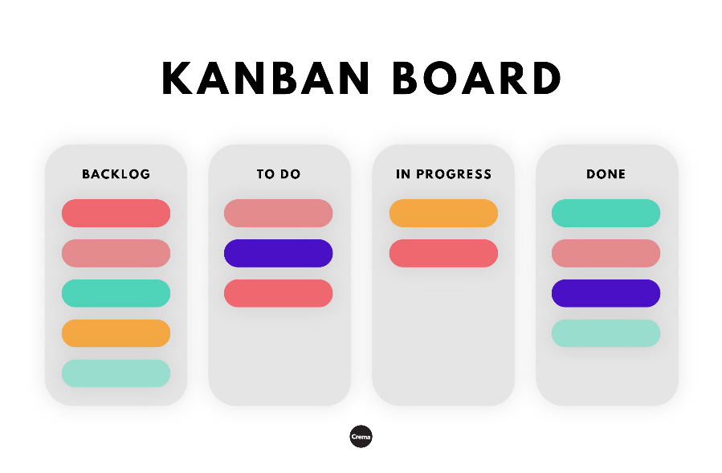

* Scrumban is a merging of the Kanban and Scrum methodologies. It combines the visualization and flexibility of the Kanban method with the structure and iterative approach of Scrum.
* **Scrum** emphasizes sprints and collective team effort to complete work quickly.
* **Kanban** focuses on visualizing tasks and finding the best workflows and processes.
* Scrum is an implementation of the agile methodology.
* Agile is a set of principles that’s iterative and incremental.

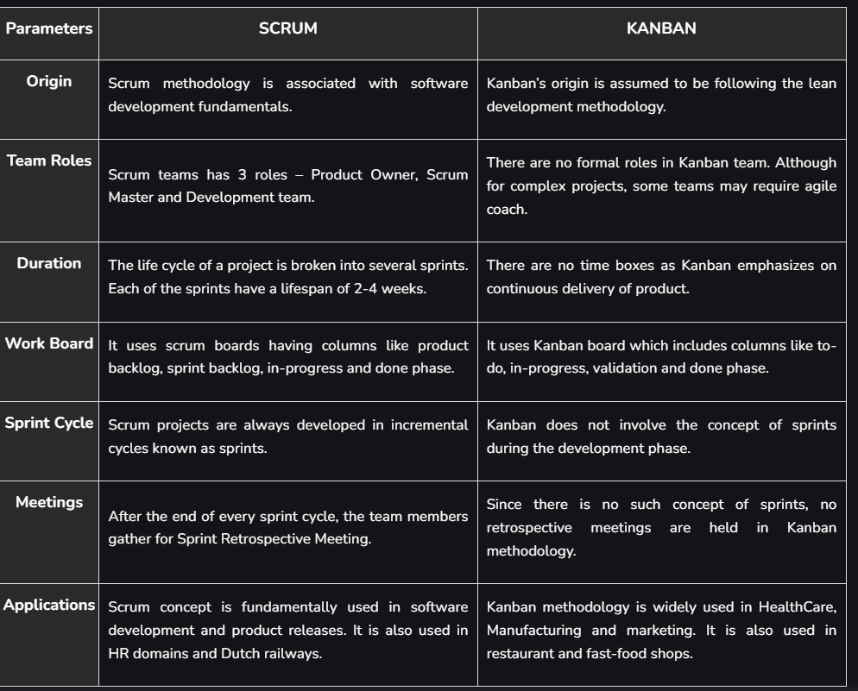

* Lean IT,
  + Lean IT is the extension of lean manufacturing and lean services principles to the development and management of information technology (IT) products and services. Its central concern is the elimination of waste, where waste is work that adds no value to a product or service.
    - Eliminate waste
    - Improve quality
    - Continuous improvement (kaizen)
    - Automate as possible
  + Here are some key principles of Lean IT:
    - Value: Focus on what the customer values and ensure that all activities contribute to delivering that value.
    - Value Stream Mapping: Identify and map all the steps in the process to understand where waste occurs.
    - Flow: Ensure that work flows smoothly through processes without interruptions or delays.
    - Pull: Produce only what is needed when it is needed, based on customer demand.
    - Continuous Improvement: Regularly seek ways to improve processes and eliminate waste
* Scrum,
* test-driven development (TDD).

Good Testing Practices:

* When Development phase starts -> Testing should also start, Early testing, Left shift
* Document review, workproducts review should be done, Test analysis and test design should be done for every level
* Each test level has each testing purpose

DEVOPS – Development(including testing), Operational – target environment (CI/CD – Jenkins)

Shift Left:

* Reviewing specifications
* TDD
* using CI/CD for fast feedback (in dev stage)
* performing static testing prior to dynamic testing
* performing non functional testing at component test level whenever possible.

Retrospective:

What went well, what didn’t went well, Improvements

Retro Benefits

* Coordination between testing and development (Team bonding and learning)
* Increased test efficiency
* Increased quality of test ware, test basis

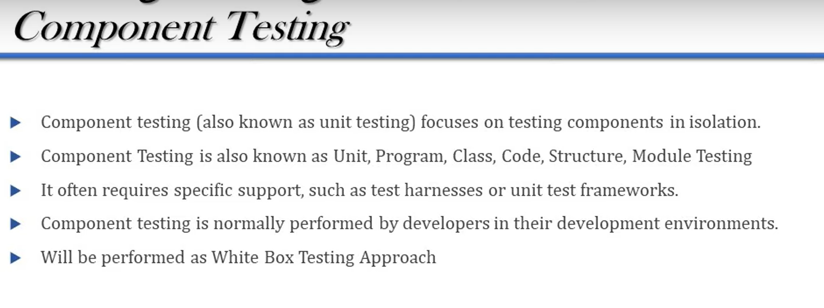

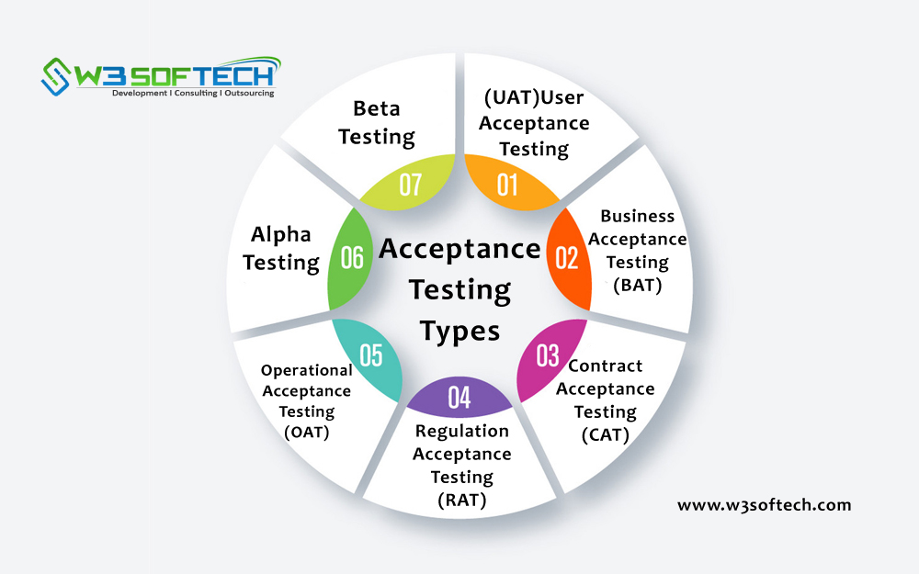

Alpha testing (pre- prod env) -customers

Beta testing (prod env) – prerelease event (real users – color, usability)

Scope of Maintenance testing:

* Size of change
* Size of existing system
* degree of risk of change

Triggers of Maintenance testing:

* Modifications
* Upgrades or migration
* Retirement

Defects or fixes happen

* Confirmation testing
  + (Retesting)
  + (testing failed tests,
  + adding new tests to cover the defect)
* Regression testing
  + (tests whether defect impacts other components, connections)
  + (CI is involved)
  + (Regression testing may not be restricted to the test object itself but can also be related to the environment.)

Static analysis tools:  
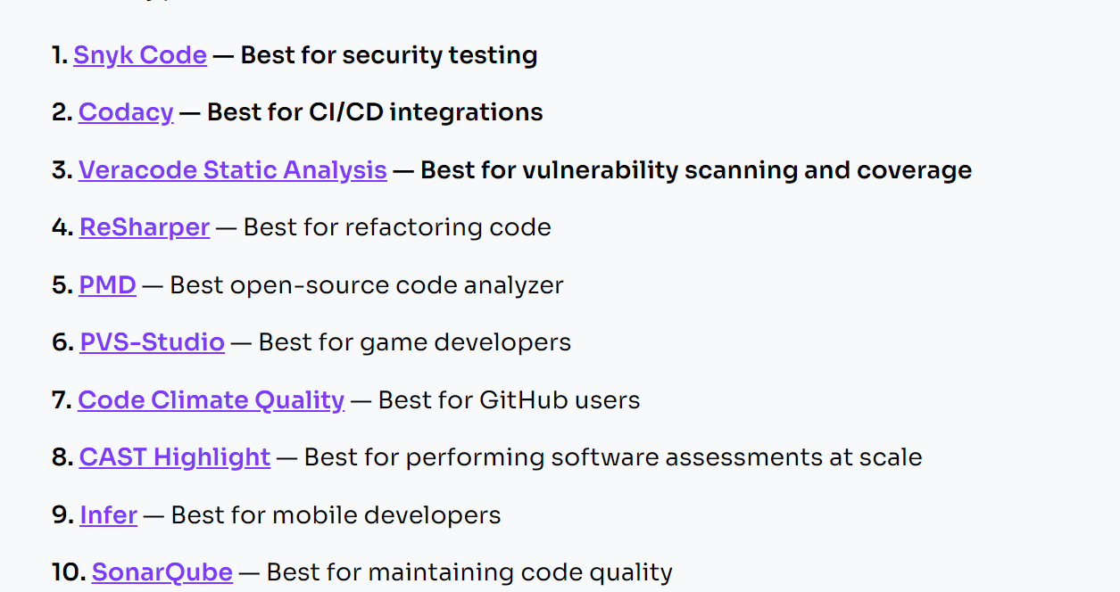

Review Process:

1. Review Planning
2. Review initiation (understanding roles and responsibilities)
3. Individual Review
4. Communication and analysis
5. Fixing and Reporting

Review Types:

1. Informal Review
2. Walkthroughs (meeting is led by author)
3. Technical Review
4. Peer Review
5. Inspection

Roles and Responsibilities:

1. Manager
2. Author
3. Scribe (recorder)
4. Moderator (Facilitator)
5. Reviewer
6. Review Leader
7. Reader

Defects:

1. Requirements
2. Coding
3. Interface
4. Design
5. Security
6. Deviation from standards
7. Gaps in Test coverage

Failures are found during dynamic testing , Defects are found in static testing

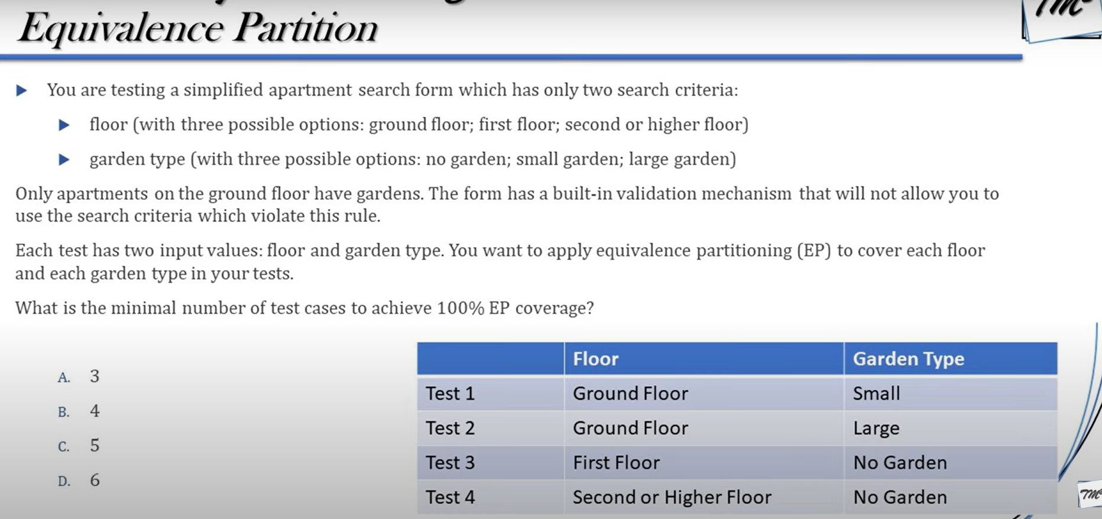

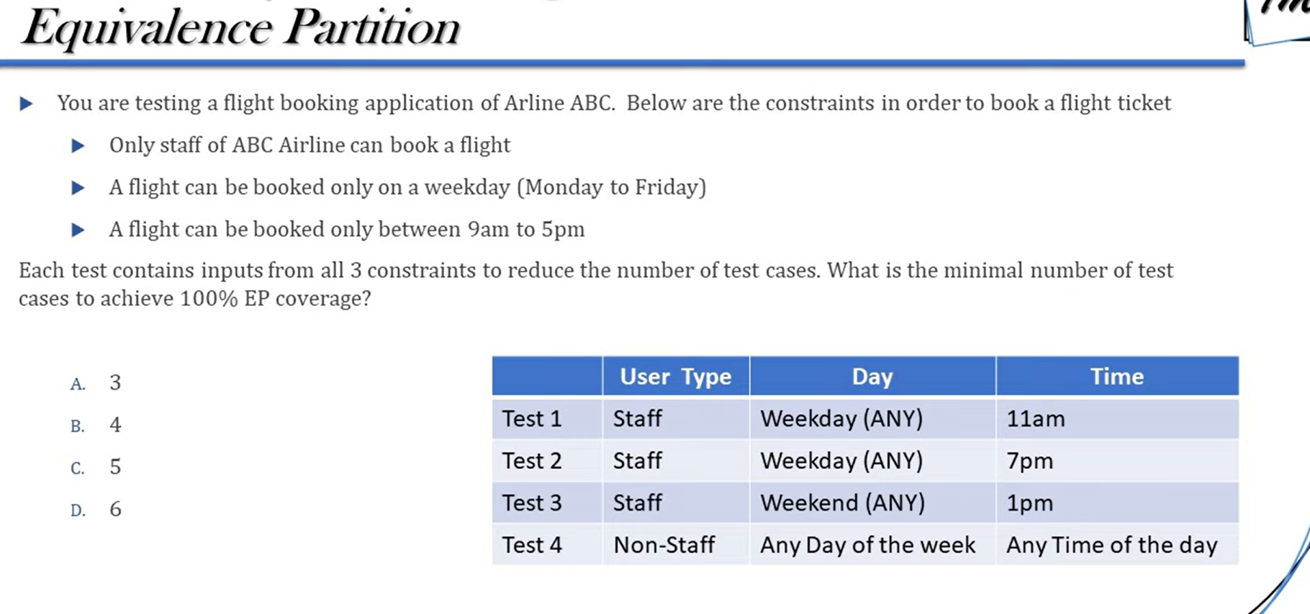

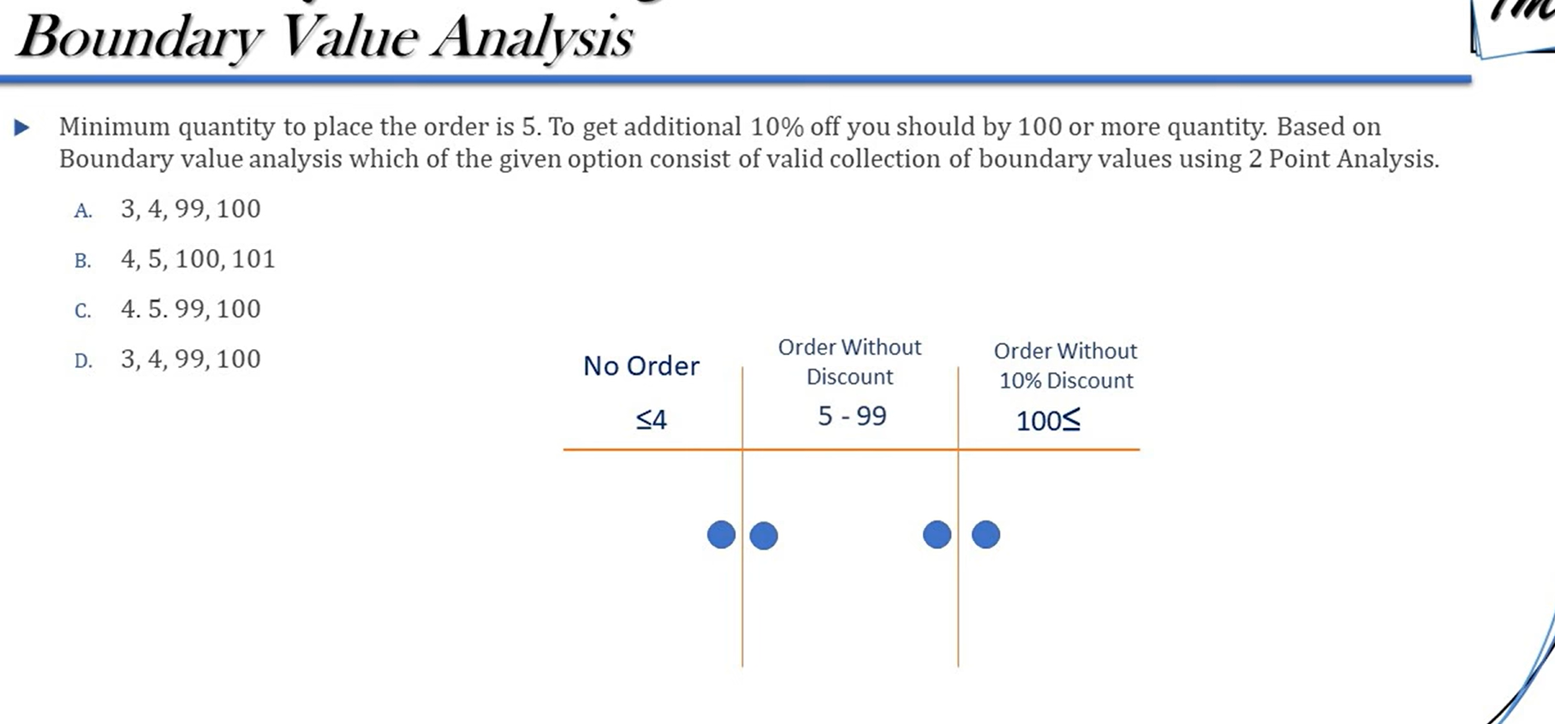

Valid collection – all values

Valid boundary values – 5, 99, 100

[Test Plan vs Test Strategy – Difference Between Them](https://www.guru99.com/test-plan-v-s-test-strategy.html)

**Test strategy Vs Test Plan:**

* Once the test strategy, test policy is developed, then test plan can be developed for a specific project.
* A **test policy** is a high-level document within an organization that outlines the fundamental principles and general guidelines for software testing.
* The test strategy includes an outline of the testing approach,
  + the types of testing to be conducted (like unit testing, integration testing, system testing, acceptance testing),
  + the testing tools
  + standards to be used,
  + the test environment configuration,
  + risk management practices,
  + resource allocations
* The test plan typically includes
  + objectives and scope of the specific test phase,
  + features to be tested, resources (human, technological),
  + detailed schedule of testing activities, (timelines)
  + the criteria for entering and exiting a testing phase (entry/exit criteria)

Test strategy: done by Project manager, owners, How to test, guidelines to be used, testing tools, types of testing, team reporting strategy, risk management practices, Communication structure, environment

Test Plan: Done by test lead or test manger, what to test, features to be tested, DOR/DOD, timelines of testing activities, Resources, test deliverables (what need to be tested), scope and objectives.

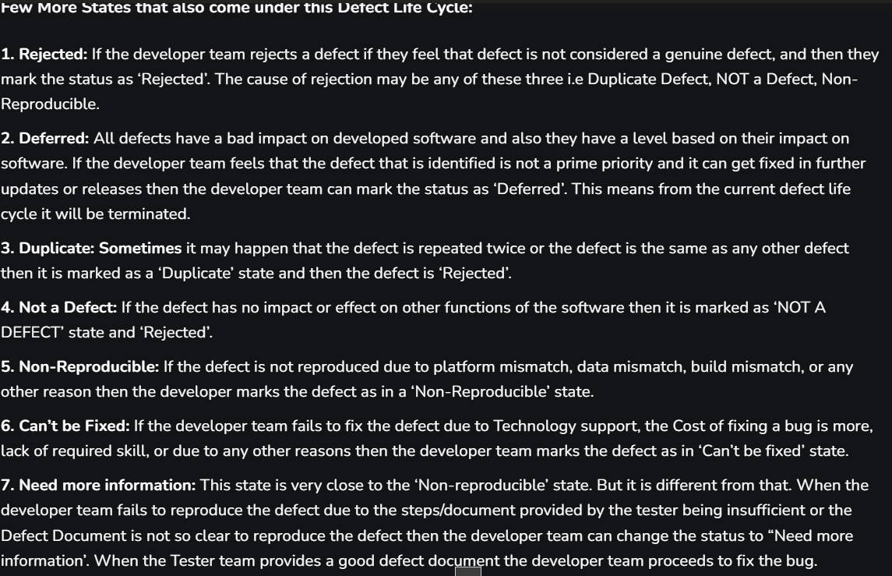

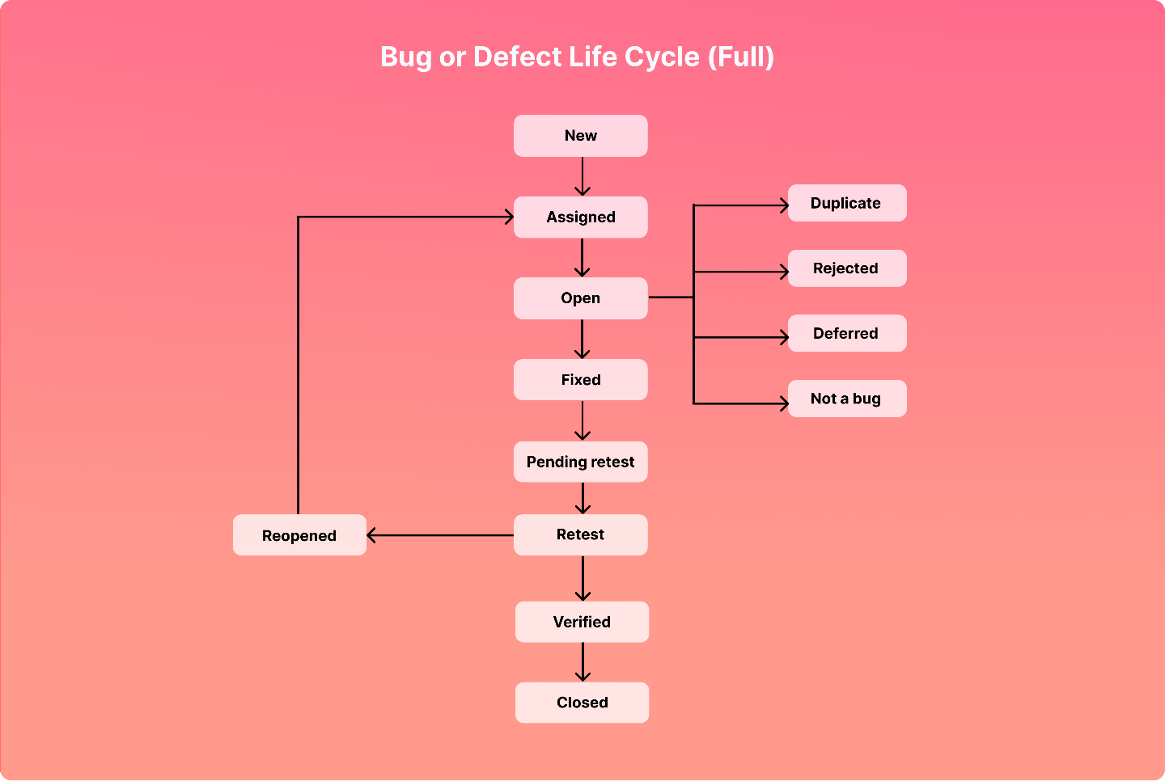

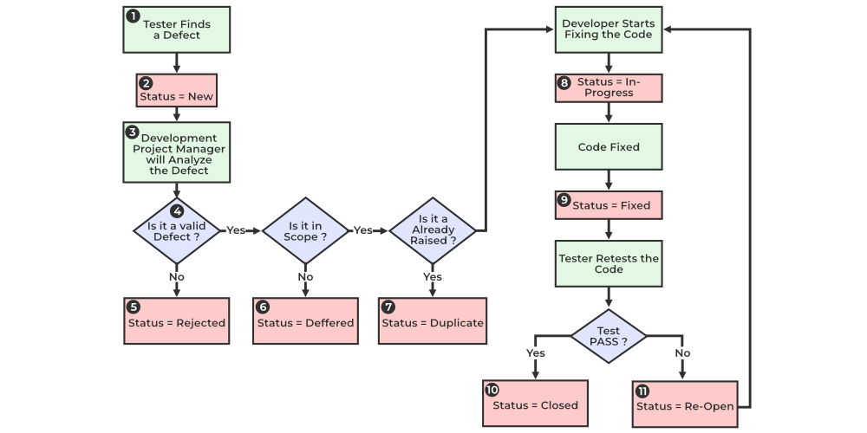

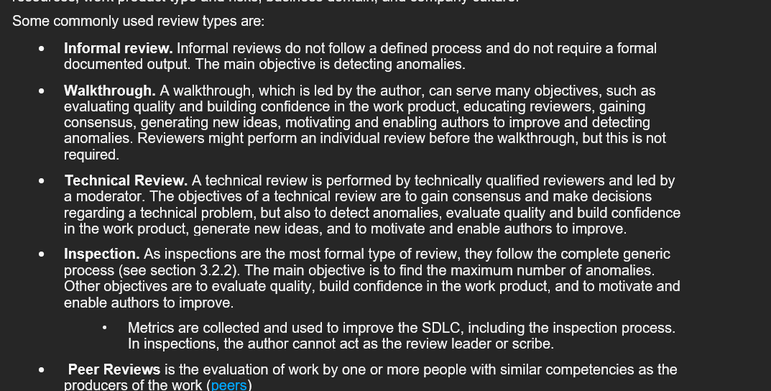

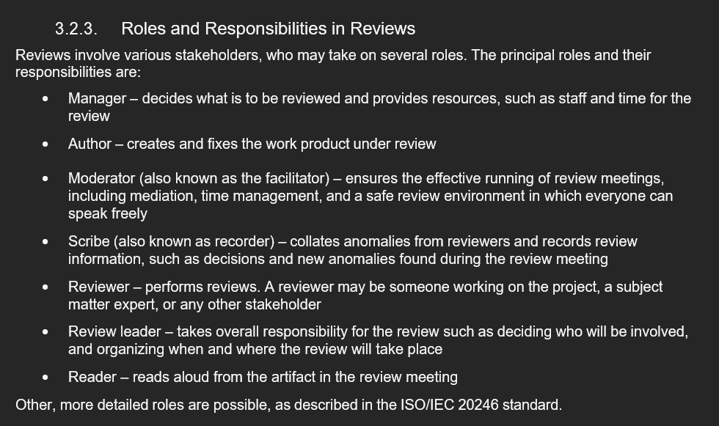

**Smoke Testing**

* **Purpose**: Smoke testing, also known as "build verification testing," is a preliminary level of testing conducted to ensure that the most crucial functions of a program work, but not bothering with finer details. It is typically done to verify whether the build is stable enough to proceed with further testing.
* **Scope**: Limited; it usually covers the basic functionalities of the application.
* **When**: Performed typically when a new build is received.

**Sanity Testing**

* **Purpose**: Sanity testing is a kind of Software Testing performed after receiving a software build, with minor changes in code, or functionality, to ascertain that the bugs have been fixed and no further issues are introduced due to these changes.
* **Scope**: Very narrow, focusing on one or a few areas of functionality. It does not go deep.
* **When**: Carried out whenever there is a minor bug fix or functional change in the application.

**Regression Testing**

* **Purpose**: Regression testing involves testing the whole application to ensure that new changes or improvements haven’t adversely affected existing functionalities. This is important for catching unintended side-effects and defects during development.
* **Scope**: Broad; covers all relevant aspects of the application.
* **When**: It is done after any changes, enhancements, or defect fixes in the software code.

Non- functional testing : we are testing performance, usability, availability of the software

Software quality refers to how well a software system meets the specified requirements, customer expectations, and user needs

A test harness is a collection of software and test data configured to test a program unit by running it under varying conditions and monitoring its behaviour and outputs. It includes test execution engines, test scripts, and test data, mocks, stubs , drivers etc

The main objectives of a test harness are to automate the testing process, increase test accuracy, and streamline the execution of multiple test cases

**Test Documentation:**

Test documentation in software testing refers to the collection of artifacts created before or during the delivery of software testing.

**Key Types of Test Documentation:**

1. **Test Policy**:
   * A high-level document that outlines the principles, approach, and major objectives of the organization regarding testing.
2. **Test Strategy**:
   * A document that outlines the test approach for the software development lifecycle. It includes test objectives, resource allocations, test environments, and schedules. It often covers the scope of testing, testing techniques, and risk identification.
3. **Test Plan**:
   * A document detailing the scope, approach, resources, and schedule of intended test activities. It identifies the test items, features to be tested, testing tasks, who will perform each task, and any risks requiring contingency planning.
4. **Test Scenario**:
   * A high-level documentation that encapsulates specific functionalities to be tested. It includes a set of conditions under which a tester will determine if a system satisfies requirements and behaves as expected.
5. **Test Case**:
   * A document specifying the inputs, expected results, and set of execution conditions for a particular test item. Test cases are designed to cover a particular scenario and include detailed steps to follow.
6. **Test Script**:
   * Similar to test cases, these can be manual scripts or automated scripts written in a programming language. They are specific instructions the software should follow during testing.
7. **Test Data**:
   * Data that exists before a test is executed, and which affects or is affected by the component or system under test.
8. **Traceability Matrix**:
   * A document, usually a table, used to trace the requirements throughout the lifecycle. It ensures transparency in relation to requirements coverage by testing.
9. **Test Report**:
   * Produced after testing concludes, this document summarizes the testing activities and results. It includes details about test coverage, defects found, severity, and whether it meets the acceptance criteria.
10. **Defect Report**:
    * A detailed account of each defect identified during testing, describing how to reproduce the issue, expected versus actual results, severity, priority for fixing, and the current status.
11. **Test Closure Document**:
    * A summary prepared at the end of the testing cycle that officially ends the testing for that specific cycle. It might include assessments of how the testing went, key insights, and any unresolved issues.

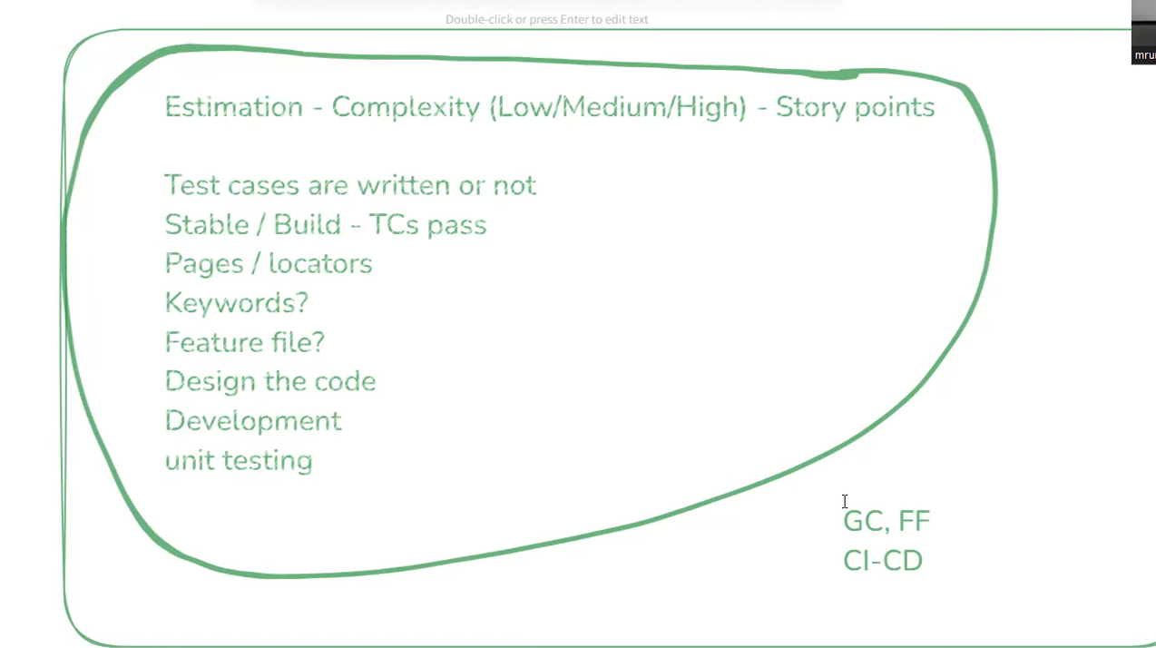

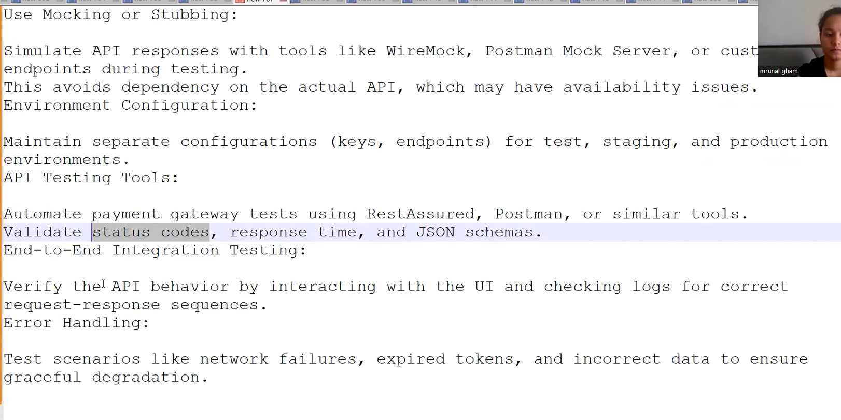

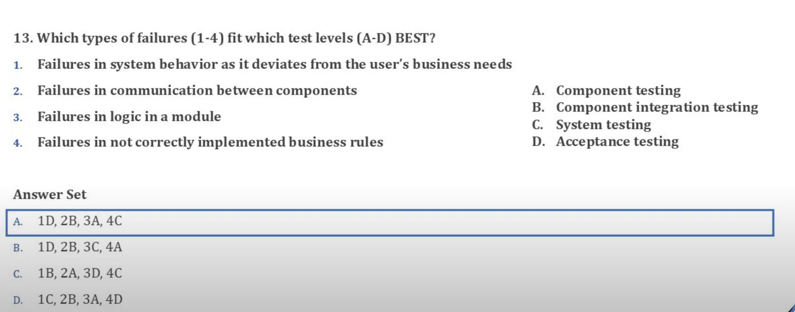

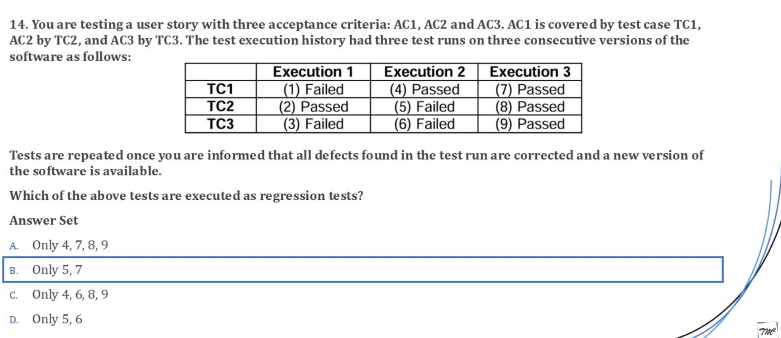

If a test pass and impacts other tests and they are executed in another execution then it is regression test